**Paradyne 9788 troubleshooting**Trap Event Log  
  
 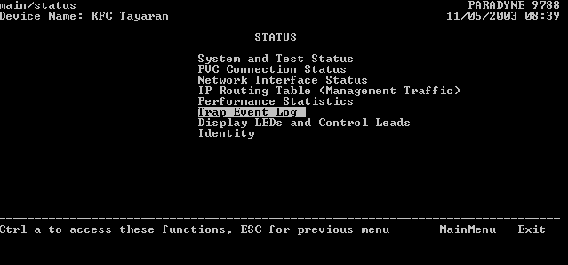

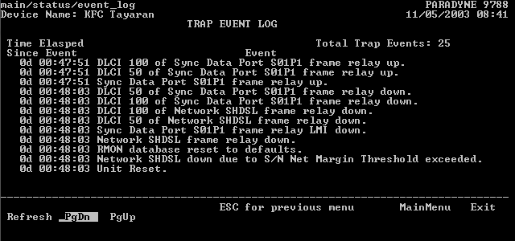

Notes:  
  
 1- all of the below alarms means that it is a physical problem [DSL problem]

a- Network SHDSL down due to S/N Net Margin Threshold exceeded  
b- ATM down due to Loss of Cell Delineation

2-don't take the below alarm into consideration when the modem is connected to zyxel DSLAM as it appear due to miss compatibility between modem and DSLAM.

-Network SHDSL down due to S/N Net Margin Threshold exceeded

To check and clear errors [Status-performance statistics- xDSL Line]  
   
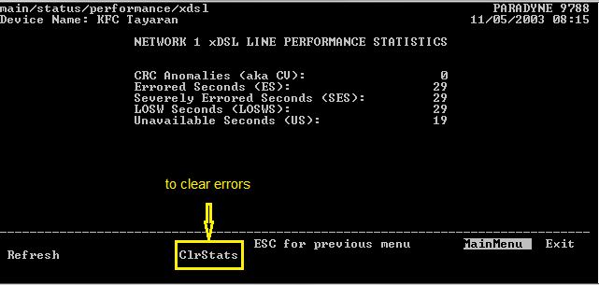  
  
  
  
   
 SNR margin [Status – NETWORK 1 INTERFACE STATUS]  
   
 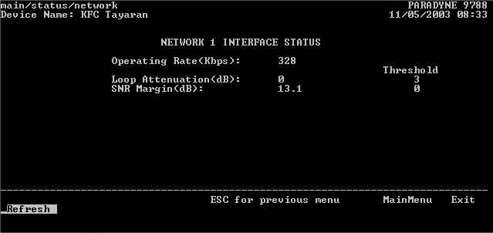  
  
  
  
  
  
  
  
  
  
  
DISPLAY LEDs & CONTROL LEADS   
  
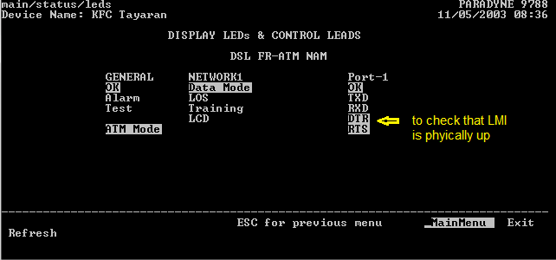

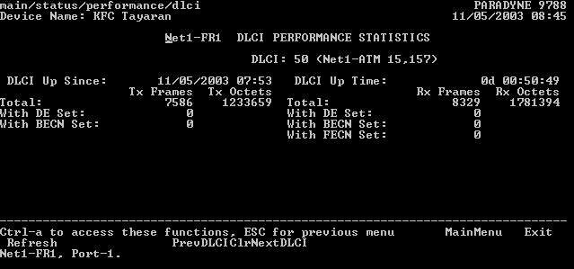   
  
To check send and receive frames [main/status/performance/dlci]  
  
 Note: this output will be useful for checking the L2 customers

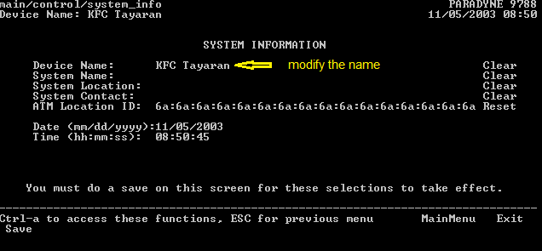 To change system name, Data and time [main/control/system info]

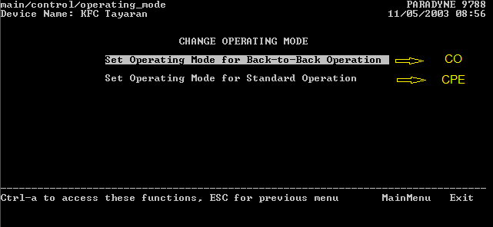To change the clocking [main/control/operating mode]

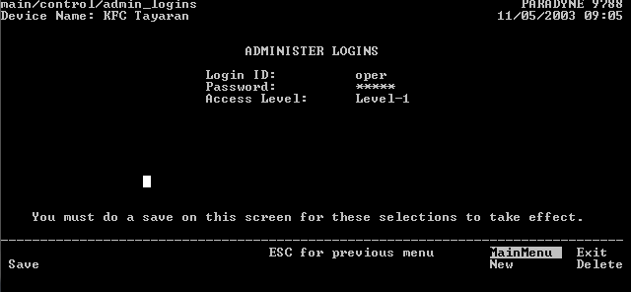 To create username and password [main/control/admin_logins]

To enable login password [main/config/management/telnet]  
  
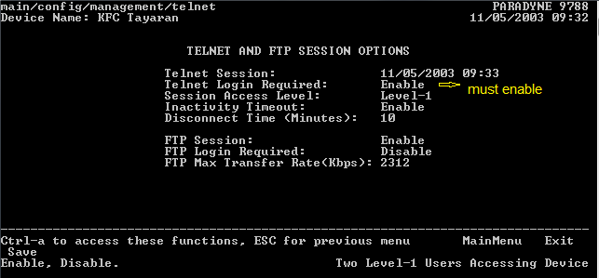

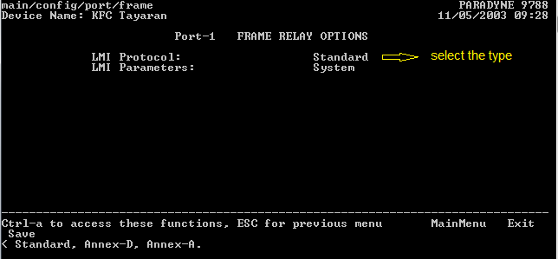 To change LMI type [main/config/port/frame]

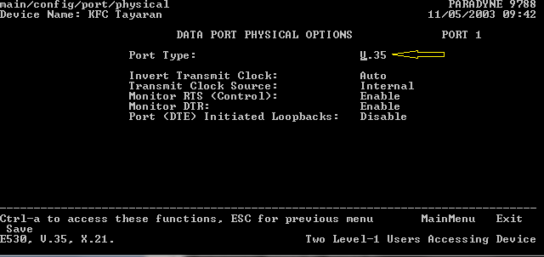To make sure that the modem's port is configured as V.35 [main/config/port/physical]

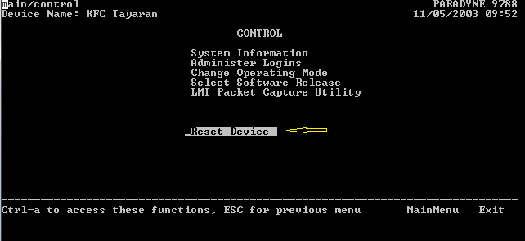To restart modem remotely[main/control]

To reset the modem to the factory setting [main/config_load]  
  
